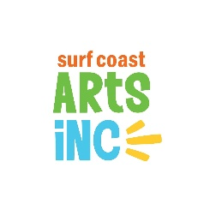
PROXY VOTING FORM
for the Annual General Meeting (AGM)
Wednesday 7 December 2022, 7pm

I, (name of Member) . . . . . . . . . . . . . . . . . . . . . . . . . . . . . . . . . . . . . . . . . . . . . . . . . . . . . . . . . . . . . . .
of (address) . . . . . . . . . . . . . . . . . . . . . . . . . . . . . . . . . . . . . . . . . . . . . . . . . . . . . . . . . . . . . . . . . . . . . ..
being a Member of Surf Coast Arts Inc hereby appoint:
(name of proxy) . . . . . . . . . . . . . . . . . . . . . . . . . . . . . . . . . . . . . . . . . . . . . . . . . . . . . . . . . . . . . . . . . .

being a Member of Surf Coast Arts Inc
of (address) . . . . . . . . . . . . . . . . . . . . . . . . . . . . . . . . . . . . . . . . . . . . . . . . . . . . . . . . . . . . . . . . . . . . .

as my proxy to vote for me of my behalf at the Annual General Meeting (AGM) of the Company to
be held on Wednesday 7 December 2022 and at any adjournment of that meeting.
Unless the proxy is directed to vote as shown below, he/she may vote or abstain as he/she chooses.
Voting directions if any: . . . . . . . . . . . . . . . . . . . . . . . . . . . . . . . . . . . . . . . . . . . . . . . . . . . . . . . . . . .
Signed this . . . . . . . . . . . . . . . . . . . day of . . . . . . . . . . . . . . . . . . . 2022
Signature of Member . . . . . . . . . . . . . . . . . . . . . . . . . . . . . . . . . . . . . . . .

Proxy holders must hand this form to the Chair of the AGM on arrival,
or email prior to surfcoastarts@gmail.com by end of business Tuesday 6 December 2022

